**TASK-3**

INNOVATION & PROBLEM SOLVING

**1.All user**

**2.User details**

**ALL USER:**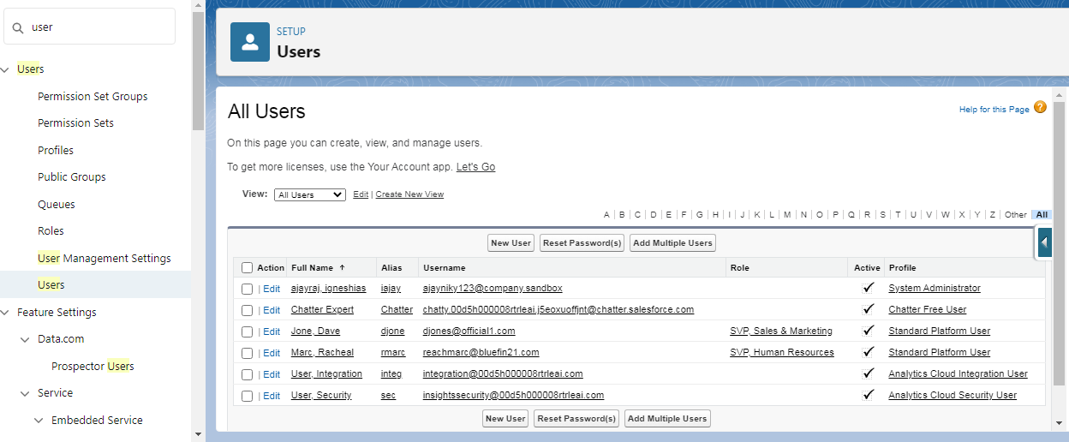

**USER DETAILS:**